## Modulette-sub_competencies table

## Fields

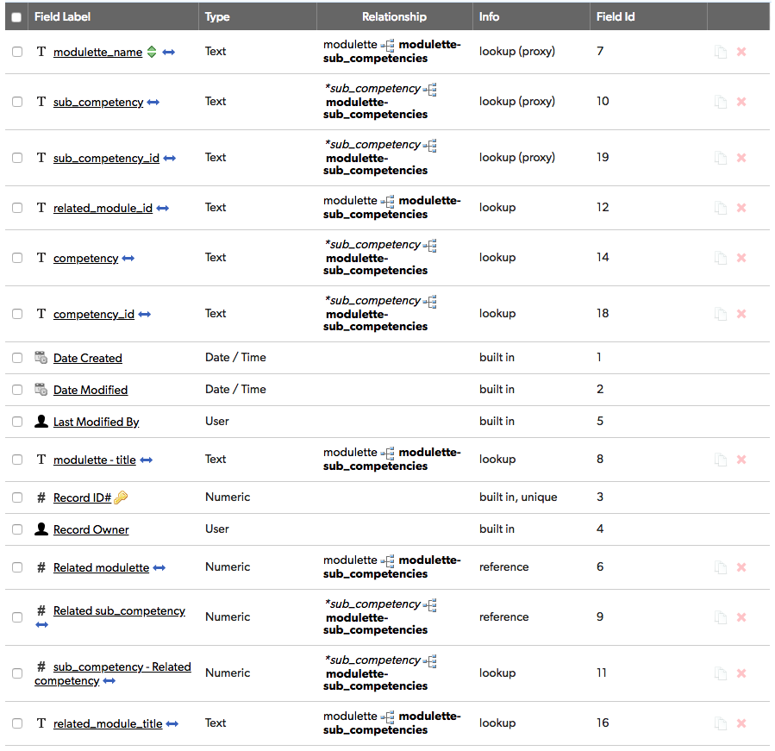

## Relationships

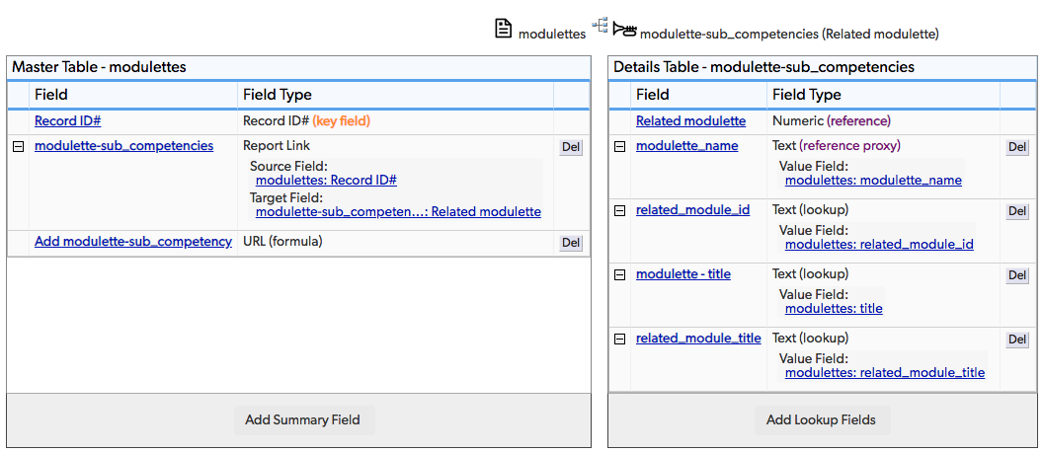

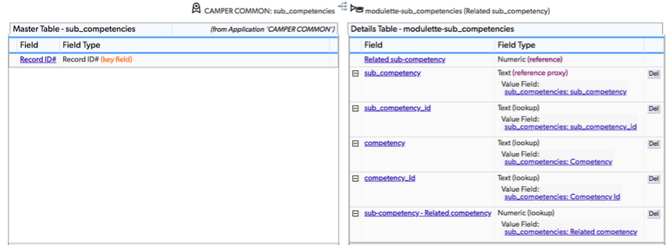

## Field settings

Note: Built-in fields use the default settings

modulette_name 3

sub_competency 3

sub_competency_id 4

related_module_id 4

competency 4

competency_id 4

modulette - title 4

Related modulette 4

Related sub_competency 4

sub_competency - Related competency 5

related_module_title 5

# modulette_name

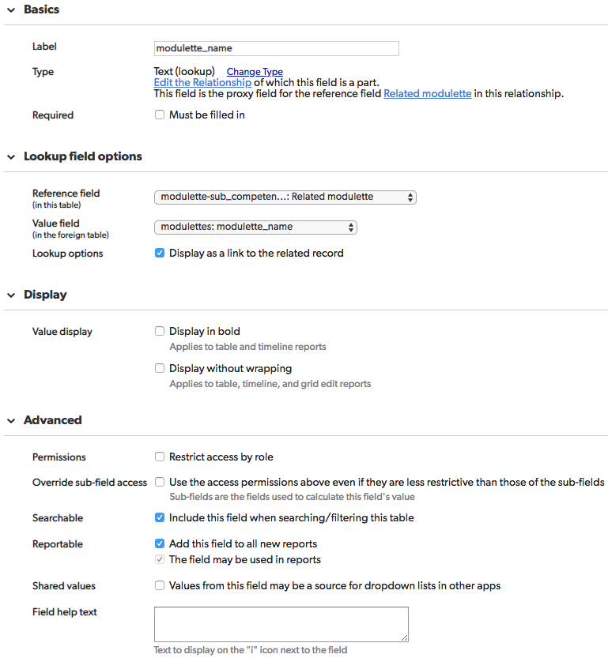

# sub_competency

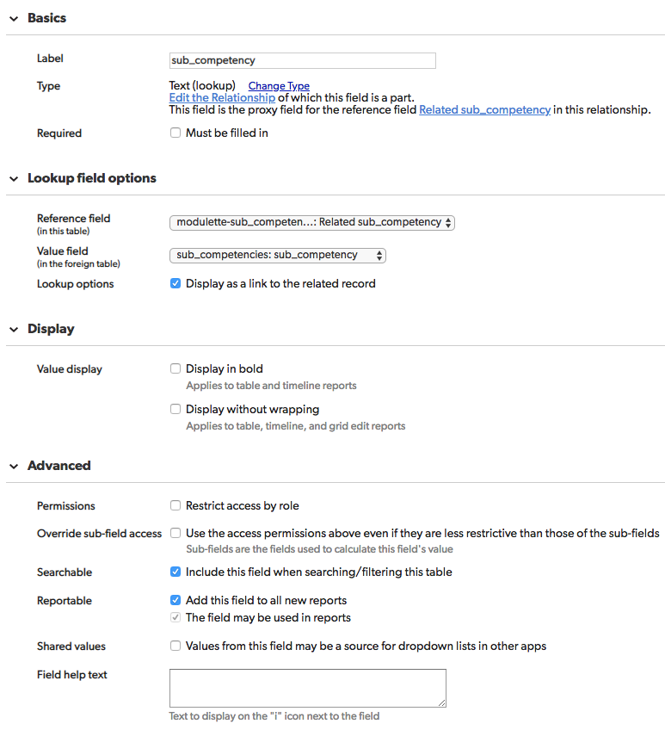

# sub_competency_id

# 

# related_module_id

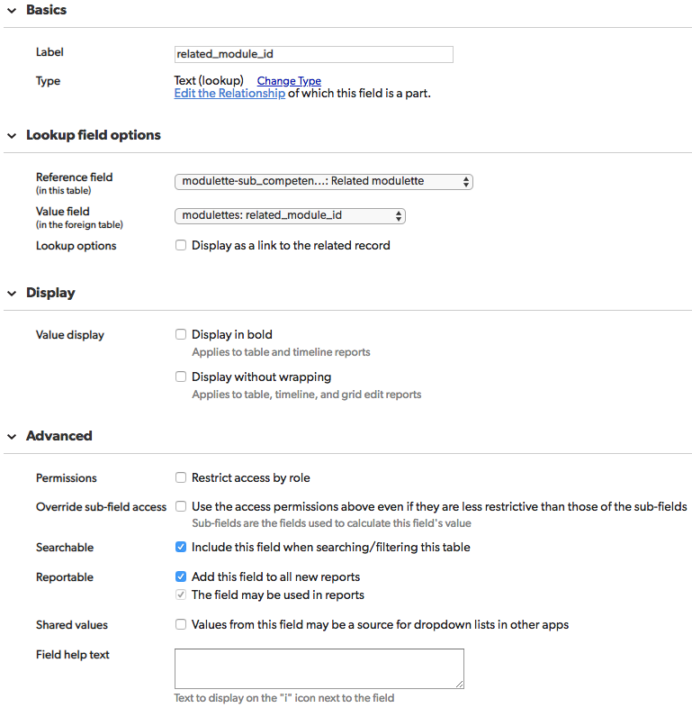

# competency

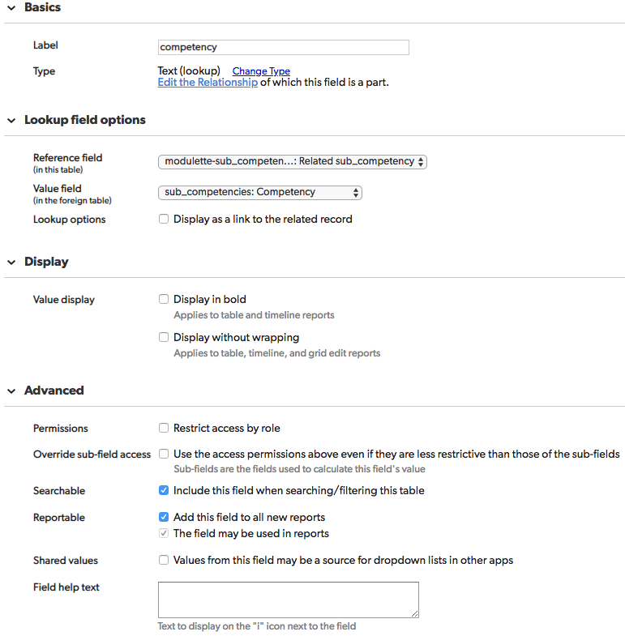

# competency_id

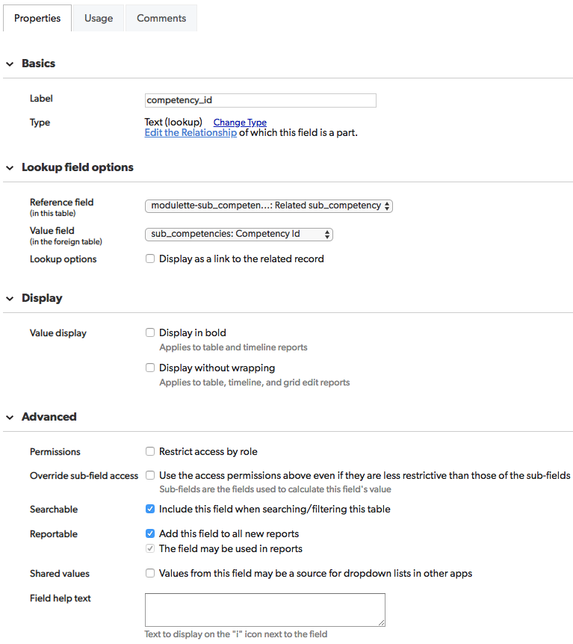

# modulette – title

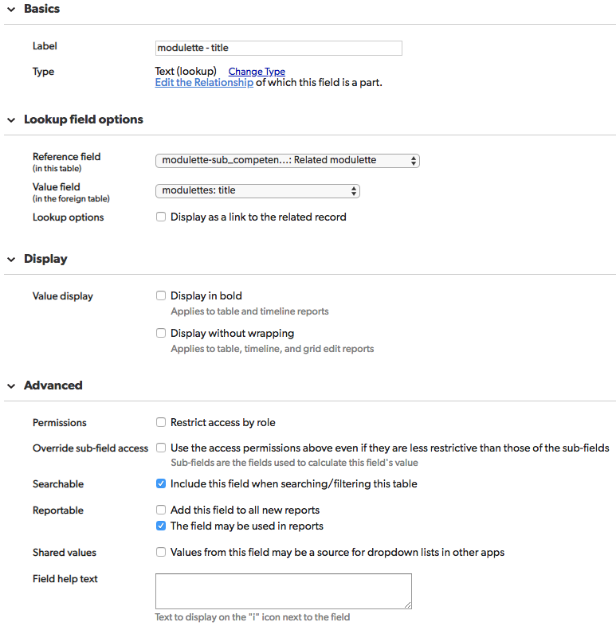

# Related modulette

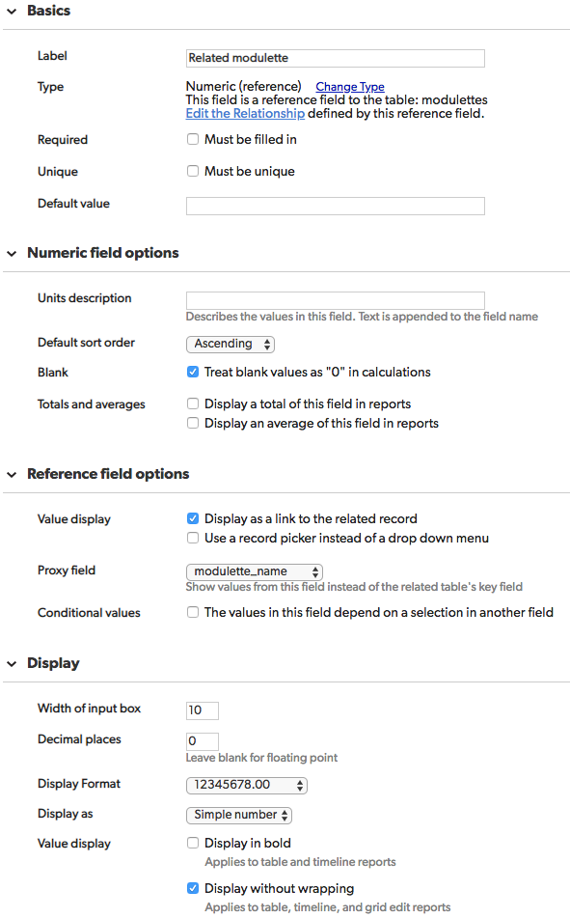

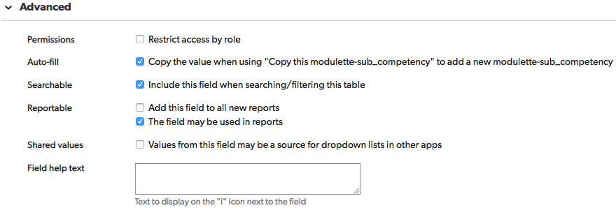

# Related sub_competency

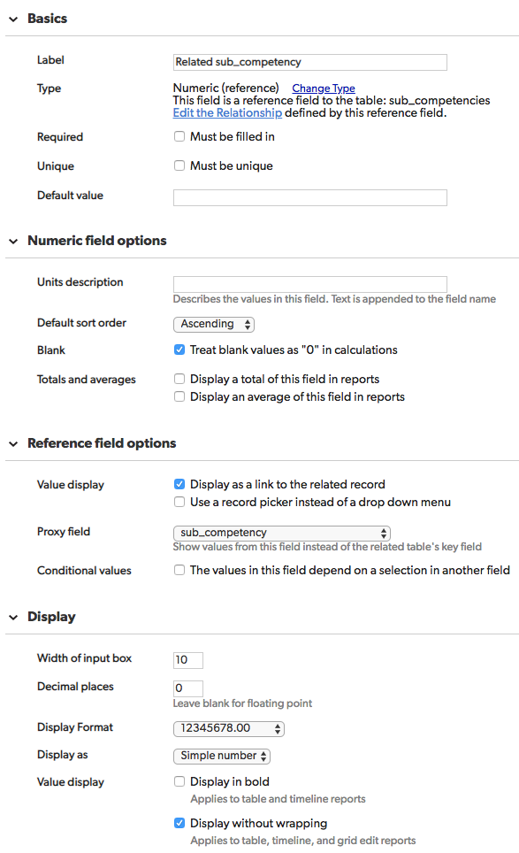

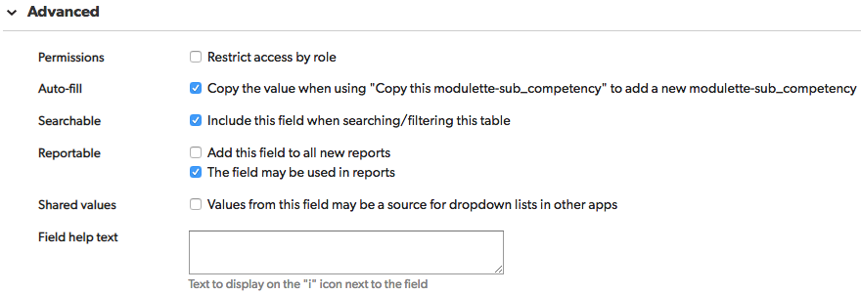

# sub_competency - Related competency

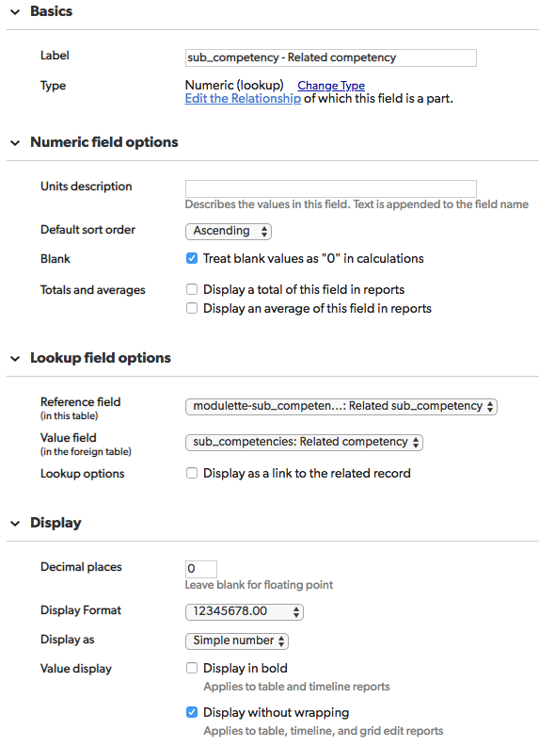

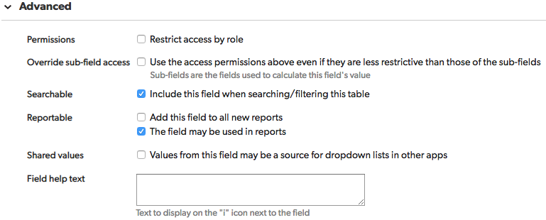

# related_module_title

